LAB2 CPE224

Member: 62070501034 Nanthakan, 62070501064 Onwipa

C:

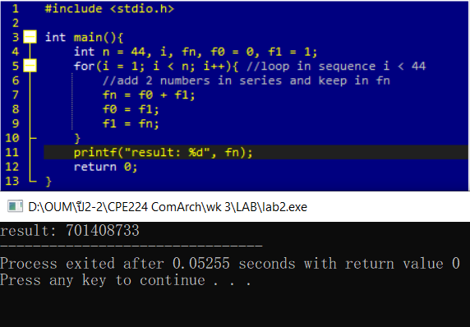

Assembly:

